[Python and Database - YouTube](https://www.youtube.com/playlist?list=PLTbN5PPRsw2sB9zFyq7q8GPv4-SaPOmcx)

[Python Programming | Connect to an Oracle database from python - YouTube](https://www.youtube.com/watch?v=6OwZvANOZaE&list=PLTbN5PPRsw2sB9zFyq7q8GPv4-SaPOmcx&index=7)

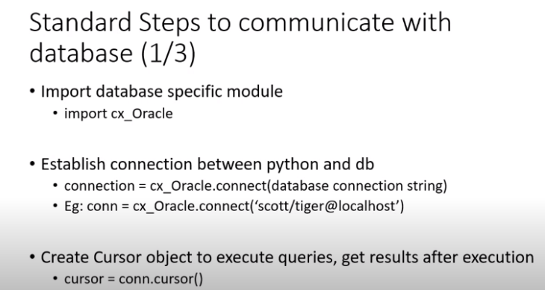 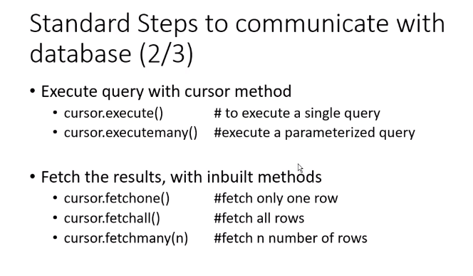

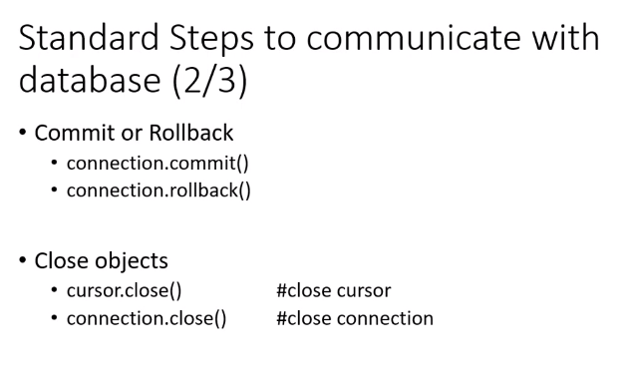 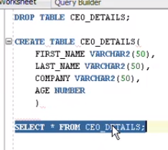 @ Oracle SQL Developer

import cx_Oracle  
import requests  
import flask  
  
cx_Oracle.init_oracle_client(lib_dir=r"C:\Oracle\instantclient_21_3")  
  
con = cx_Oracle.connect('TRAINEE19/TRAINEE19@//192.168.0.99:1521/rmclient')  
print(con.version)  
  
cur = con.cursor()  
  
sql_create = """  
CREATE TABLE CEO_DETALS(  
 FIRST_NAME VARCHAR2(50),  
 LAST_NAME VARCHAR2(50),  
 COMPANY VARCHAR(50),  
 AGE NUMBER  
)  
"""

cur.execute(sql_create)  
print('Table Created.')

------------------------------------